|  |  |  |  |
| --- | --- | --- | --- |
| logo ngan.png | | **MINISTRY OF EDUCATION AND TRAINING** | |
| **FPT UNIVERSITY** | |
| **CAPSTONE PROJECT DOCUMENT** | |
| **BUILDING A WEBSITE SUPPORT THE ACTIVITIES “TIẾP SỨC MÙA THI” CAMPAIGN**  **Project Report #3 – System Requirements Specifications** | |
|  | |
| |  |  | | --- | --- | | **Group 22** | | | **Group Members** | |  |  | | --- | --- | | SE60769 | Nguyen Duy Khoa | | SE60687 | Le Nguyen Huu Tri | | 60358 | Nguyen Dinh Tuan | | 60325 | Tran Nguyen Kim Vinh | | 60339 | Nguyen Vinh Hien | | | **Supervisor** | Nguyen Trong Tai | | **Ext Supervisor** | N/A | | **Capstone Project Code** | TSMT | | |
| - Ho Chi Minh City, February 2014 - | |

Table of Contents

3. Software Requirement Specification 3

3.1. User Requirement Specification 3

3.1.1. Guest Requirements 3

3.1.2. Authorized User Requirements 3

3.1.3. Candidate Requirements 3

3.1.4. Charity Requirements 3

3.1.5. Volunteer Requirements 3

3.1.6. Sponsor Requirements 3

3.1.7. Admin Requirements 3

3.2. System Requirement Specification (Specific Requirements) 3

3.2.1. External Interface Requirements 3

3.2.2. Functional Requirements 3

3.2.3. Non-functional Requirements 3

3.3. Entity Relationship Diagram or Data Structure 4

3.3.1. Entity Relationship Diagram 4

3.3.2. Entity Detail 4

# SOFTWARE REQUIREMENT SPECIFICATION

## User Requirement Specification

### Guest Requirements

### Authorized User Requirements

### Candidate Requirements

### Charity Requirements

### Volunteer Requirements

### Sponsor Requirements

### Admin Requirements

## System Requirement Specification (Specific Requirements)

### External Interface Requirements

#### User Interfaces

#### Hardware Interfaces

#### System Interfaces

#### Communication Protocol

### Main Flow Overviews

### Functional Requirements

#### Overall Use case diagram

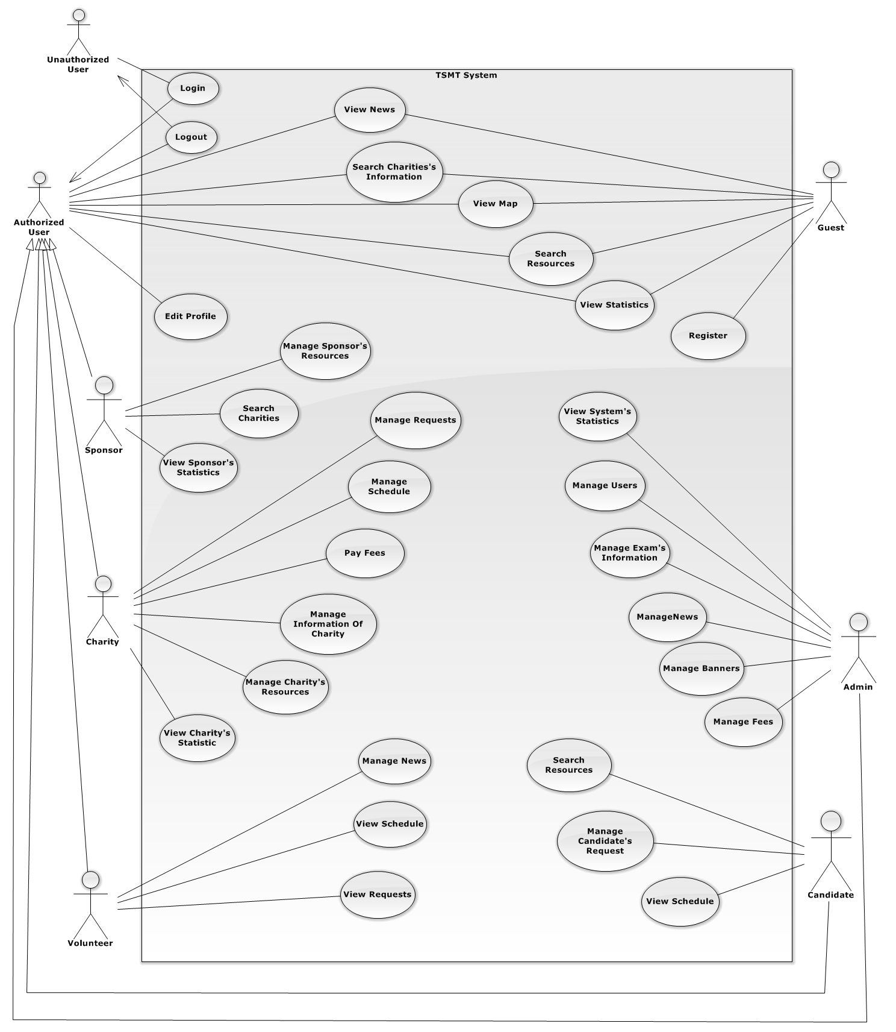

#### ⏪Unauthorized User⏩ Login

#### ⏪Authorized User⏩ View News

#### ⏪Authorized User⏩ Search Charity’s Information

#### ⏪Authorized User⏩ View Map

#### ⏪Authorized User⏩ Search Resource

#### ⏪Authorized User⏩ View Statistics

#### ⏪Authorized User⏩ Comment

#### ⏪Authorized User⏩ Edit Profile

#### ⏪Authorized User⏩ Logout

#### ⏪Guest⏩ Register

#### ⏪Guest, Authorized User⏩ Search Charity’s Information

#### ⏪Guest, Authorized User⏩ Search Resources

#### ⏪Guest, Authorized User⏩ View Map

#### ⏪Guest, Authorized User⏩ View News

#### ⏪Guest, Authorized User⏩ View Statistics

#### ⏪Charity⏩ Manage Charity’s Information

#### ⏪Charity⏩ Manage Request

#### ⏪Charity⏩ Manage Resource

#### ⏪Charity⏩ Manage Schedule

#### ⏪Charity⏩ Pay Fees

#### ⏪Charity⏩ View Charity’s Statistics

#### ⏪Sponsor⏩ Manage Sponsor’s Resources

#### ⏪Sponsor⏩ Search Charity

#### ⏪Sponsor⏩ View Sponsor’s Statistics

#### ⏪Volunteer⏩ Manage News

#### ⏪Volunteer⏩ View Request

#### ⏪Volunteer⏩ View Schedule

#### ⏪Candidate⏩ Manage Candidate’s Request

#### ⏪Candidate⏩ View Schedule

#### ⏪Candidate⏩ Search Resource

#### ⏪Admin⏩ Manage Advertising

#### ⏪Admin⏩ Manage Exam’s Information

#### ⏪Admin⏩ Manage News

#### ⏪Admin⏩ Manage User

#### ⏪Admin⏩View System Statistics

### Non-functional Requirements

#### Reliability

#### Availability

#### Security

#### Maintainability

#### Portability

#### Performance

## Entity Relationship Diagram or Data Structure

### Entity Relationship Diagram

### Entity Detail